# Installing Minikube Kubernetes environment

Download kubectl.exe and place it in the directory: C:\Windows

Download the minikube-installer.exe file, and execute the installer. This will automatically add minikube.exe to your path with an uninstaller available as well

C:\Program Files (x86)\Kubernetes\Minikube should have been added to the %path%

Open CMD and verify they are installed and functional

C:\Users\ramosa>**kubectl version**

Client Version: version.Info{Major:"1", Minor:"10", GitVersion:"v1.10.0", ...

C:\Users\ramosa>**minikube version**

minikube version: v0.25.2

Now install the Minikube environment with “minikube start”

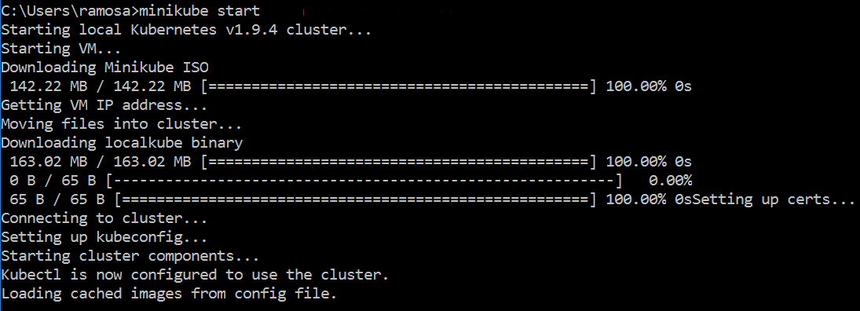

A VM gets created in VirtualBox

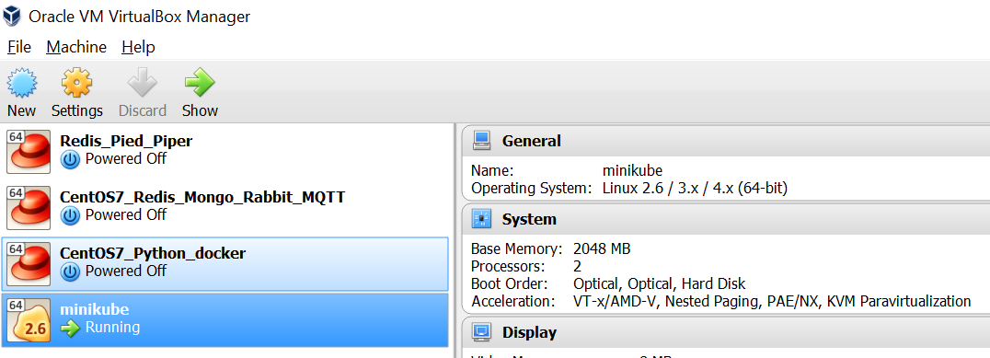

Open the port forwarding settings of the VM to see what port you need to use for SSH into the VM

Settings > Network > Advanced > Port Forwarding

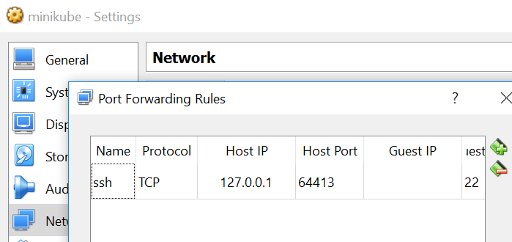

In my case it has created a mapping for port “64413”. Now we can use Putty

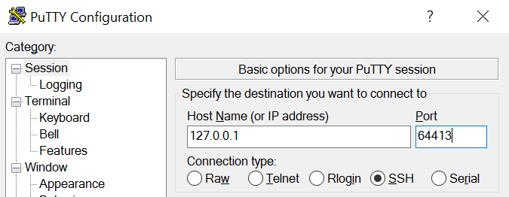

You can log on as:

username = docker

password = tcuser

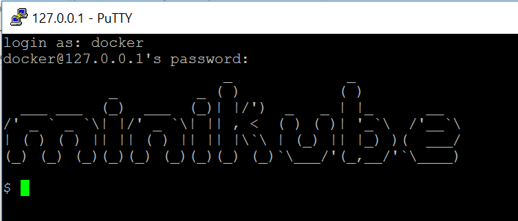

Verify Docker is running in the environment by typing “docker ps”

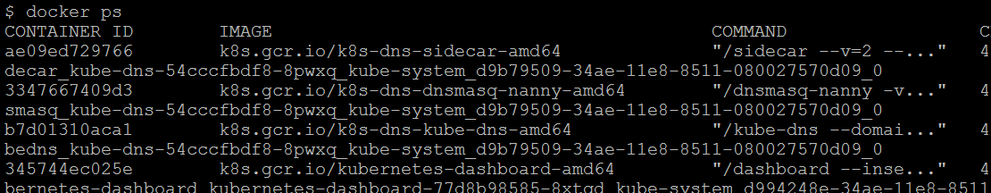

Back in the DOS prompt verify kubectl can see the Kubernetes cluster with “kubectl cluster-info”

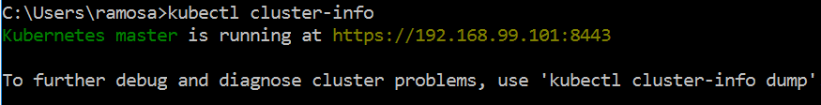

Do not shut down the virtual machine. If you want to close VirtualBox you can just “suspend” the VM.

If for whatever reason the virtual machine gets shut down you can restart the whole environment again from CMD typing “minikube start”